## Lesson 5 – Activity Sheet

## Getting Started

[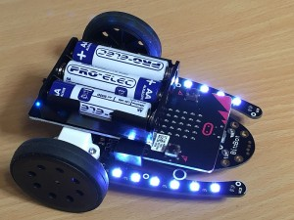](http://4tronix.co.uk/blog/wp-content/uploads/2016/12/bb01.jpg)

The Bit:Bot is a great way to develop you coding skills and can be used with both the block based language and extended for use with Python

The Bit:Bot has the following features

* 2 motors – both fully controllable in software, for both speed and direction
* Wheels with rubber tyres for maximum grip
* 12 Neopixels (programmable multicoloured LEDs) in 2 sets of 6 along the arms either side
* 2 digital line following sensors
* 2 analogue light sensors
* Buzzer to make beeping sounds whenever you want
* Integrated 3×AA battery holder
* Easily plug your BBC micro:bit in and out using the edge connector
* Expansion connections at the front for additional sensors (eg ultrasonic distance sensor)

## Success Criteria

* Identify all the components to assemble your Bit:Bot
* Correctly assemble your Bit:Bot
* Test your Bit:Bot’s basic functionality uses the codes from Lessons 4 and 5

## Pro-tip

## Check the version of your Bit:Bot. Versions prior to 1.2 the Bit:Bot will go into paired mode due to the implementation of the line sensors. To stop this lift the Bit:Bot off the surface before powering up.

## Test Time

* Is the micro:bit in with LEDs facing up?
* Are all screws and blots tightened up with the wheels on the right way round?
* Does your Bit:Bot move forwards, backwards and spin
* Do the LEDS display?
* Does the buzzer function?

## Stretch Tasks

* Attach the ultrasonic sensor
* Check all ultrasonic distance sensors for functionality
* Check the light sensors give reading
* Check the line sensors digital output

## Final Thoughts

In this lesson we have looked at the features of the Bit:Bot, followed the assembly instructions and then tested to see if the basic functions work.